You are invited to participate in the Chattahoochee Valley Citizen Corp’s CERT Rodeo Round UP!
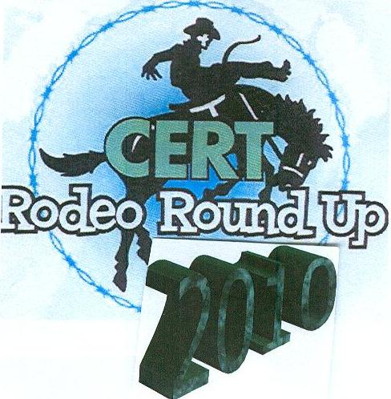

Saturday, October 30, 2010
9:00 a.m. to 2:00 p.m. EST
Team Set Up 8:00am
- Participate in a series of events using skills learned in the 9-week CERT training…basic medical operations, search and rescue, fire suppression, incident command, and other team building activities.
- CERT members must bring own equipment and supplies (issued to you when you graduated from the CERT course).

Participate or Volunteer, Get Involved….Your Community Needs You!
Registration form attached to this flyer.

The CERT Rodeo will take place (RAIN or SHINE) at:
The 14th Street Walking Bridge downtown
Columbus, Georgia and Phenix City, Alabama
(between Country’s BBQ and TSYS on the Georgia side and directly behind the
Russell County Courthouse on the Alabama side)
To view a map visit:

To Register Contact: Jan Boswell at: boswell@rcema.us or 334-291-5079 or
Yolanda Strong at ystrong@dhr.state.ga.us 706-321-6150
To Volunteer Contact: Tamber Fuller at: tdfuller@dhr.state.ga.us or 706-321-6150

NOTE:
The Chattahoochee Valley Citizen’s Corps requires ALL volunteers – CERT members as well – to complete a release form. The form can be requested in advance from Jan Boswell or Tamber Fuller.
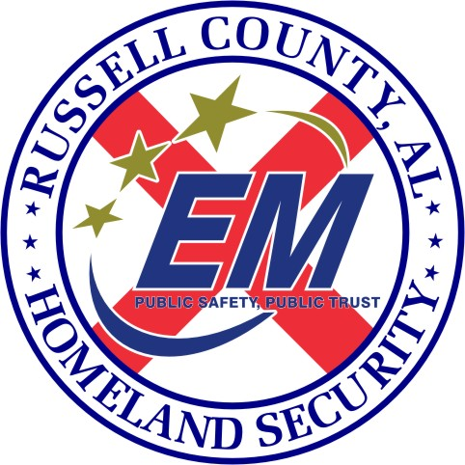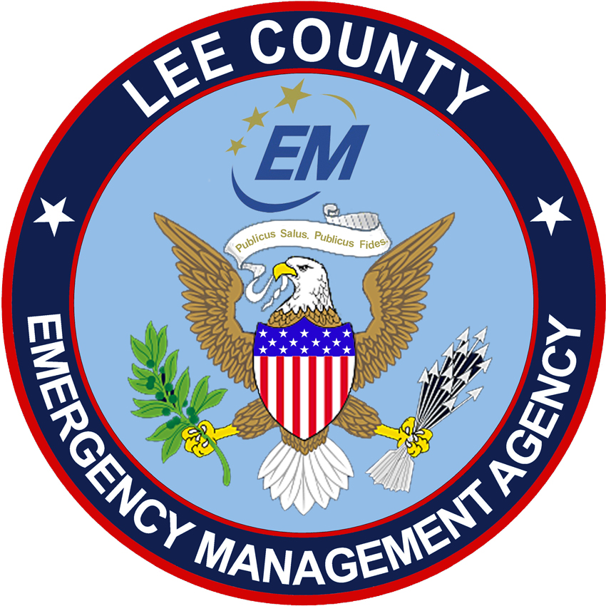

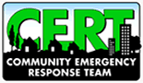

REGISTRATION FORM

REGISTRATION DEADLINE DATE: Thursday, October 28, 2008
Please place an “X” in the appropriate box: |  | Mr. |  | Ms.
Name (F, MI, L):
Job Title:
Organization:
Address:
City, State, Zip:
Job Phone: |  |  | Fax:
E-mail:
FAX OR EMAIL YOUR REGISTRATION TO: Jan Boswell ,Russell County Office of Homeland Security / Emergency Management Fax: 334-448-9178 or boswell@rcema.us (or) Yolanda Strong at ystrong@dhr.state.ga.us 706-321-6150
Note:
- All volunteers & participants must be at least 18 years of age.*
- All volunteers are required to complete a “Registration Form and Liability Release” form. Children under 18 years of age can participate as a volunteer if the “Registration Form and Liability Release” is co-signed by a parent or legal guardian AND a notarized parental/Guardian release form is attached.
- Remember to return release forms with registration forms

I have agreed to participate in the Chattahoochee Valley Citizen’s Corps CERT Rodeo, led by the Russell County Emergency Management Agency and the West Central Health District- Columbus Health Department and understand that I will not be paid for my services and will not be covered by workers’ compensation insurance as are employees of the Russell County Emergency Management Agency and the West Central Health District and Columbus Health Department.
As a participant in the CERT Rodeo, I release the Citizen’s Corps, CERT program, Russell County Emergency Management Agency, West Central Health District, Columbus Health Department and their officials, employees, agents, volunteers, and other participating agencies and/or organizations, their officers, directors, employees, agents and any participants from all liability of any kind whatsoever including, but not limited to claims, demands, actions or causes which may arise out of my participation and waive all rights which I may have against the Citizen’s Corps, CERT program, Russell County Emergency Management Agency, West Central Health District, Columbus Health Department, and their officials, employees, agents and volunteers, and other participating agencies and/or organizations, their officers, directors, employees, agents, and any participants.
Furthermore, I agree that I will not assist any other person or entity in making a claim or bringing a legal action against the Citizen’s Corps, CERT program, Russell County Emergency Management Agency, West Central Health District, Columbus Health Department, and their officials, employees, agents, volunteers, and other participating agencies and/or organizations, their officers, directors, employees, agents, and any participants for any matter which might arise out of my participation in the CERT Rodeo.
I understand that my attendance and involvement in the Rodeo is strictly voluntary and that I am participating at my own risk.
I further irrevocably give the Citizen’s Corps, CERT program, Russell County Emergency Management Agency, West Central Health District, Columbus Health Department, and its assigns and successors, my consent to use my name, any photograph, likeness, image, voice, videotape, sound recording and biography made of me or in which I may be included in whole or part in any and all media, publications, advertising and publicity in connection with my participation with the CERT Rodeo-Citizen’s Corps-CERT program and any Citizen’s Corps-CERT program activity or project. Additionally, by signing this document, I release and forever discharge the Citizen’s Corps, CERT program, Russell County Emergency Management Agency, West Central Health District, Columbus Health Department, and their officials, employees, agents, volunteers, and other participating agencies and/or organizations, their officers, directors, employees, agents, and any participants from any and all claims or liabilities of any kind which may arise from the use of my likeness. I acknowledge and agree that I will not receive any compensation in connection with any use of my likeness.
I hereby acknowledge that the Chattahoochee Valley Citizen’s Corps is an organization involved in assisting organizations and associations which may from time to time be involved with child care and related matters. Prior to volunteering, I agree to have a background check if needed for the event announced. I hereby confirm, represent and warrant that I have never been convicted of or charged with a violent crime, or any crime involving or relating to child abuse or neglect, child pornography, child abduction, or any other violent offense, including kidnapping, rape or any sexual offense, nor have I ever been ordered by a court to receive psychiatric or psychological treatment in connection with such crime or crimes.

I have read and agree to the foregoing terms and conditions of this Volunteer Release Agreement.

_________________________________________________________________________________________
Signature Date

If you are under the age of 18, please have a parent or guardian sign the following:
I am the parent or guardian of ________________________________________and I have read and agree to his/her participation in the Chattahoochee Valley Citizen’s Corps program to the foregoing terms and conditions of this Volunteer Release Agreement.

_________________________________________________________________________________________
Signature of parent or guardian Date

(09/2010)

