Amplifiers

Purpose: The objective of this activity is for the students to explore simple amplifiers.

Overview: “Turn that thing down!”…how many times have the students heard those agitated words? Most of the students have a good grasp of amplification - louder is better when listening to contemporary music. But have they considered that the actual voltages generated by the CD or tape are incredibly small and would not produce the desired volume that they would like when listening to their favorite artist. Virtually all bands have carloads of ‘Amps’ that they use during their performances. Amplification is what this activity is all about.
Amplification is the process of increasing the strength of a signal. The amount that the signal is strengthened by the amplifier is called the gain of the amplifier. Voltages and currents used in wireless technology are incredibly small. Consider the basic concept that a wave loses strength as it travels at a rate approximately inversely proportional to the square of the distance traveled. Even very high-powered commercial broadcast stations create voltages on a receiver antenna that are in the millionths of a volt range. Amplifiers therefore are an important building block of electronics because they increase the strength of weak currents so that they can be used.
In this activity, a simple circuit will be used to demonstrate the concept of amplification.

Time: Fifteen minutes to set up the demonstration board and the oscilloscope. One class period to demonstrate the fundamentals of amplifiers.

Skills Required:

- Listening
- Observation
- Critical thinking
- Writing and expression

Materials and Tools:

- The demonstration board
- Voltmeter
- Oscilloscope

Preparation:

- Review with the students the properties of AC current.

- Review with the students the vocabulary needed to describe a waveform (wavelength, frequency, cycle, crests, trough, positive side, negative side, and amplitude).

- Review with the students the relationship between amplitude and the strength of the wave. Ensure that the students understand that amplification modifies the strength (amplitude) of the wave, but does not ideally modify any other property of the wave (shape, frequency, etc.).

- A good analogy to use to explain the concept of amplification is to use a sink water valve as an example. The purpose of a sink water valve is to control the flow of water into the sink. A small force to turn the valve open, causes the flow of water to increase; an opposite turn causes the flow to decrease. If the students were to try and control the flow of water, under full pressure, with their thumbs, they would spray water all over the place with humorous results. In an amplifier, the small voltages are applied to the input of the circuit to cause an increased flow of current (at higher voltages and currents) on the output, and vice versa. A string of amplifiers connected in series can allow incredibly small currents to replicate themselves as incredibly large currents. The analogy to the valve is so good that the British refer to transistors and vacuum tubes, the primary component of an amplifier circuit, as valves.

Background:

Now You’re Talking pages 7.4.

ARRL Handbook pages 8.6.

Basic Electronics pages 15.1-15.4.

What to do and how to do it:

- Connect one channel of the oscilloscope to the output of one of the oscillators. Task the students to note the peak voltage of the waveform produced by the oscillator. They should also note the wave shape and frequency for later comparison to the amplified wave.

- Connect the oscillator to the input of the amplifier and connect the second channel of the oscilloscope to the output of the amplifier. Task students to note the peak voltage of the waveform on the output of the amplifier. They should also note the wave shape and frequency of the output waveform.

- Vary the amplitude of the input waveform and observe the resulting output of the amplifier.

- The students share their observations with the rest of the class.

Data Analysis:

- Assign students to compare in their journals the input to the output waveforms (compare frequency, wavelength, and amplitude).

- Assign the students to calculate the gain, or amount of amplification, that was achieved by the amplifier.

Activity questions:

- Do you have amplifier equipment in your home? If so, why?

- Did you see any change in the waveform from the input compared to the output of the amplifier? Use the vocabulary of AC waves to make your comparison.

- How did you calculate the gain of the amplifier? What does gain mean in plain English?

- Do you think there is a limit to that amount of amplification possible? If so, what would cause that limit?

- What happens if you turn your amplifier at home too high? Are there any precautions listed on your home amplifier? If so, why do they have these precautions?

- Many communities have, or are contemplating, city ordinances restricting the use of amplifiers. What is the motivation for these restrictive ordinances? How do you feel about the government restricting your use of your amplifier? Offer an alternative.

- Compare the audio output of a crystal radio with that of the typical home stereo unit. What is the difference? What makes this difference?

Adaptations for special needs: There may be substantial accommodations required for this activity depending of the need. Hearing impaired students will be able to detect amplitude changes by touching a speaker connected first at the oscillator and then to the amplifier output. Visually impaired students may need a tactile manipulative that simulates the sine wave form displayed on the oscilloscope. Tactile waveforms with various wavelengths prepared before the class period can be made out of corkboard with push pins and rubber bands or yarn. The pushpins are placed at points along the sine wave plot and the rubber bands or yarn are formed along the points of the plot.

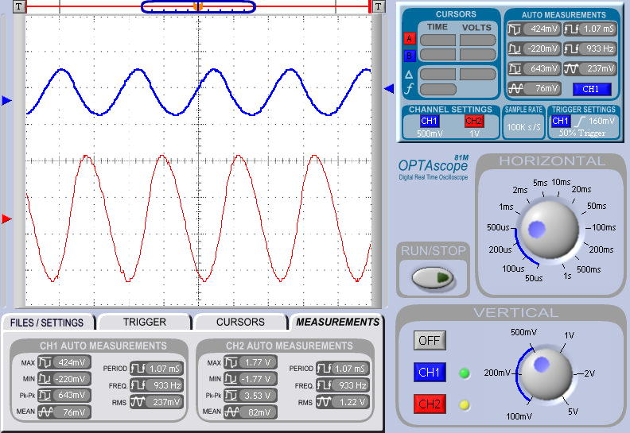

The upper trace is the input to the amplifier. The scale of that trace is 500 MV. The lower trace is the output of the amplifier. The scale of that trace is 1V. Visual inspection of the traces reveals that the amplifier increases the signal by a factor of 5.4.

