Mixers

Purpose: The objective of this activity is for the students to explore simple mixer circuits.

Overview: Mixers are important blocks in any wireless system. Just as the name implies, mixers combine two signals. For instance, one use of a mixer in a radio is to combine two frequencies, one collected by the antenna and one generated by an variable frequency oscillator controlled by the tuning dial. The combination of these two frequencies allows the user of the radio to select the desired frequency that is then passed to other parts of the radio for filtration and additional processing. Without the mixer, a dedicated radio would be required for each frequency of interest.
Mixers can be thought of as frequency adding and subtracting circuits because the output of the mixer is actually two frequencies, the sum and the difference of the input frequencies. If the mixer input frequencies are 660 Hz and 2000 Hz, the output of the mixer would be 2660 Hz (2000+660) and 1340 Hz (2000-660). The output waveform of these two combined frequencies appears to be complex, but with careful observation, the two frequencies can be seen.
In an actual wireless system, the output of the mixer is fed to a set of filters that would attenuate the undesirable frequencies and pass the desired frequency to the next stage of the system.

Time: Fifteen minutes to set up the demonstration board and the oscilloscope. One class period to demonstrate the fundamentals of mixers.

Skills Required:

- Listening
- Observation
- Mathematics
- Critical Thinking
- Writing and expression

Materials and Tools:

- The demonstration board
- Oscilloscope

Preparation:

- Review with the students the properties of AC current (see background material).

- Review with the students the vocabulary needed to describe a waveform (wavelength, frequency, cycle, crests, trough, positive side, negative side, and amplitude).

- Review with the students the mathematics used when combining frequencies:
f₂ + f₁ and f₂ – f₁. This may be a good time to introduce the concept of harmonic wave generation.

Background:

Now You’re Talking pages 11.3, 8.4 – 8.8.

ARRL Handbook pages 15.1 – 15.36.

What to do and how to do it:

- Connect the output of the fixed oscillator on the activity board to one input channel of the mixer circuit and the variable frequency oscillator (VFO) to the second channel. Also connect one channel of the oscilloscope to each oscillator channel. Adjust the VFO frequency to the maximum frequency. The graphic of figure 1 is representative of the frequencies applied to the input of the mixer from the activity board.

- Using the automatic frequency measurement capability of the oscilloscope or the more accurate manual method using the cursors, task the students to record the frequencies of each input wave. The students can now predict the output frequencies of the mixer by calculating the sum and difference of the two input frequencies.

- Now remover the oscilloscope probes from the mixer input connections and connect one channel to the output of the mixer. The resulting waveform should look like the one represented in figure 2. Task the students to study the complex waveform and detect any repetitive pattern within the waveform. Careful observation will show that there are two repetitive patterns; one for each cycle of ridges and troughs, and one for repeating spike like ridges and troughs.

- Using the oscilloscope cursor method to measure frequency, task the students to measure the frequency of each of the two repetitive patterns displayed on the output of the mixer. Figures 3 and 4 illustrate the positioning of the cursors on the two patterns.

- Task the students to compare the frequencies measured on the output of the mixer to the predictions calculated in number 2 above.

- To gain additional insight into the operation of the mixer, vary the VFO frequency from the high to the low frequency extreme and observe the oscilloscope pattern of the output of the mixer. Task the students to make journal entries of their observations for later discussion.

Data Analysis:

- Assign students to compare the input to the output waveforms in their journals (compare frequency, wavelength, and amplitude).

- Using graph paper and two manually generated waveforms, assign the students to create a graph of a mixed signal that results from the combination of the two signals. This can be accomplished by dividing the x-axis of the waveform presentations into equal increments, and then numerically adding and subtracting the y-axis value of each waveform. Creating a data table would help keep the data organized. Plotting a new graph using the same x-axis increment and the sum of the y-axis values will result in a mixed signal graph.

- Students may also use the power of Excel Spreadsheets to generate the graphs mentioned in number 2 above. An example of spreadsheet-generated graph is shown in figure 5.

Activity questions:

- Do does a mixer circuit do?

- Did you see any change in the waveform from the input compared to the output of the mixer? Use the vocabulary of AC waves to make your comparison.

- Did the mixer output frequencies match the predicted frequencies?

- What would you predict the output of the mixer would be if the two input frequencies were exactly the same?

- What would you predict the output of the mixer would be if the two input frequencies were 1000 Hz and 2000 Hz?

Adaptations for special needs: There may be substantial accommodations required for this activity depending of the need. Visually impaired students may need a tactile manipulative that simulates the waveform displayed on the oscilloscope. Tactile waveforms with various wavelengths prepared before the class period can be made out of corkboard with push pins and rubber bands or yarn. The pushpins are placed at points along the waveform plot and the rubber bands or yarn are formed along the points of the plot. An audio amplifier connected to the input signals and the mixer output in-turn would provide an auditory demonstration of signal mixing.

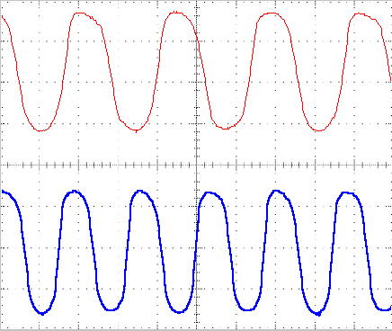
f₁ = 833 Hz
f₂ = 1130 Hz
Figure 1.

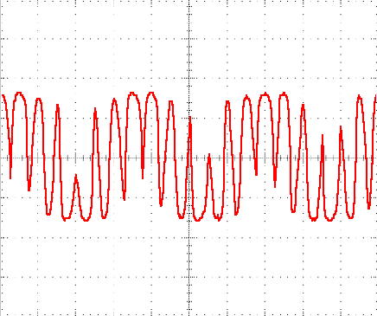
Figure 2.

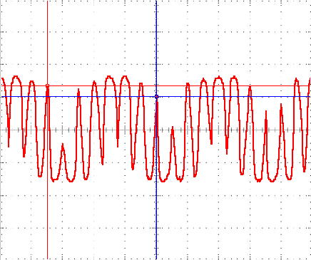
f₂-f₁ = 283 Hz

Figure 3.
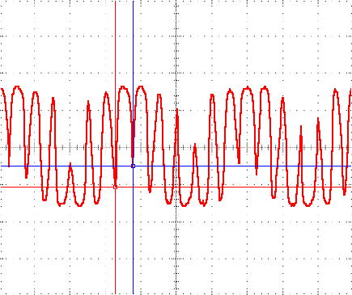
f₂+f₁=1960Hz

Figure 4.

Figure 5.

