Oscillators

Purpose: The objective of this activity is for the students explore oscillators.

Overview: Oscillators are one of the basic building blocks of electronics. The purpose of the oscillator is to generate alternating currents from a direct current supply. Oscillators can generate very low, sub-audible frequencies and very high frequencies in the microwave radio frequency range. This activity uses a simple audio oscillator called the twin-T oscillator. Two of the oscillators are set at fixed frequencies and one oscillator can have its frequency varied through a small range.
The oscillator circuits will be used in this lesson to demonstrate the function of the oscillator but also in later units when filters and mixer blocks are studied. The variable frequency oscillator can be used to demonstrate the relationship between frequency, pitch, wavelength, and amplitude. A small audio amplifier tied to the output of the variable oscillation would be useful in the demonstration of this relationship.

Time: Fifteen minutes to set up the demonstration board and the oscilloscope. One class period to demonstrate the fundamentals of oscillators.

Skills Required:

- Listening
- Observation
- Critical thinking
- Writing and expression

Materials and Tools:

- The demonstration board.
- Voltmeter
- Oscilloscope
- Audio amplifier (optional)

Preparation:

Review with the students the two types of electric current (AC and DC) and the properties of each.

Review with the students the vocabulary needed to describe a waveform (wavelength, frequency, cycle, crests, trough, positive side, negative side, and amplitude).

Background:

Now You’re Talking pages 2.1-4.

ARRL Handbook pages 6.1-3.

Basic Electronics 16-7 – 16-9

What to do and how to do it:

- Set up the oscilloscope and connect one channel of the scope to the DC voltage supply. Have the students record their observation of the waveform present and describe what the waveform display is telling them about the voltage being sampled.

- Connect the second channel of the scope to the output of the variable frequency oscillator (VFO). Have the students record their observations of the waveform present and describe what the waveform display is telling them about the peak voltage and the period in seconds.

- If connected, turn on the audio amplifier and have the students listen to and note the pitch of the oscillator for later comparison.

- Change the frequency of the VFO from the low to high end of the frequency range and repeat as often as needed. Have the students record their observations of the waveform presented and describe what the waveform display is telling them about the peak voltage and period in seconds.

- If connected, turn on the audio amplifier and have the students listen to and note the pitch of the VFO for later comparison.

Data Analysis:

- Assign the students to create waveform drawings in their journals and label each component of the waveform with the data collected from their scope observations.

- Assign the students to calculate the frequency of the first two waveforms and compare their calculated values with the actual frequency of the preset oscillators.

- Ask the students to describe in their journals the relationship they observed between frequency, wavelength, and pitch.

Activity questions:

- What happens to the pitch (tone) that the wave produces as the wavelength gets shorter?

- What was the waveform of the electric current that supplied power to the oscillator? What was the shape of the waveform of the electric current of the output of the oscillator?

- When the wavelength of the last oscillator was changed, what happened to the amplitude of the wave? What happened to the period? What happened to the pitch?

- What is the relationship between frequency and pitch?

- What is the relationship between frequency and period?

- What is the relationship between wavelength and frequency?

- An oscillator converts what type of current into what other type of current?

- In normal every-day language, what does the term amplitude mean?

Adaptations for special needs: There may be substantial accommodations required for this activity depending of the need. Hearing impaired students will be able to detect amplitude and pitch changes by touching the amplifier speaker. Visually impaired students may need a tactile manipulative that simulates the sine wave form displayed on the oscilloscope. Tactile waveforms with various wavelengths prepared before the class period can be made out of corkboard with push pins and rubber bands or yarn. The push-pins are placed at points along the sine wave plot and the rubber bands or yarn are formed along the points of the plot.

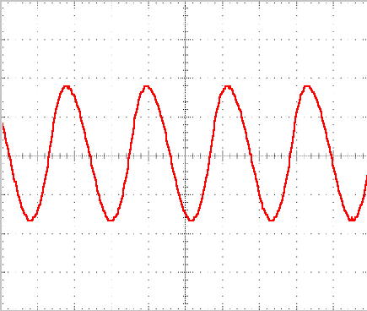
Crest
Trough
Amplitude
Wave
Length

Component | 750Hz | 1800Hz | Variable
R1-R2 | 18k | 15k | 10-20k
R3 | 1800 | 1500 | 1650
R4 | 3.3k
C1 | .05uF | .02uF | .033uF
C2-C3 | .02uF | .01uF | .02uF
C4 | .1uF

