Rectifiers

Purpose: The objective of this activity is for the students to explore simple rectifiers.

Overview: Rectifiers convert alternating currents (AC) into direct current (DC). Alternating currents reverse direction each cycle while direct current moves in only one direction. All wireless technology depends on DC for the power source. When wireless devices are portable, such as a cell phone, boom box, handheld transceiver, or global positioning system (GPS), the power source comes from batteries, which produce DC by chemical reaction. When these same devices are used in the home or a more permanent location where commercial power is available (from a wall outlet) a converter is used to change the current from the home (AC) into current the device can use (DC) to operate or recharge the batteries. You may be familiar with the small box that plugs into the wall outlet that has a connecting cord to the wireless device. These small boxes are sometimes called wall-warts. The circuitry inside these boxes is a rectifier.
The basic component that makes the rectifier work is the diode. These small devices are like one-way valves, they allow current to only flow in one direction. If a current tries to flow in the opposite direction, it is stopped by the diode. If you look at an AC waveform, you see a sine-wave shape with one portion of the wave on the positive side of the y-axis and one side on the negative side. If this wave were applied to a diode, one half of the wave would be allowed to pass through (depending on the direction of the diode) and the other half would be blocked. The current allowed to pass will have only one polarity, and that means only travels in one direction. Current that travels in only one direction is DC. Therefore the diode rectifies the AC and converts it into DC.
The DC that comes out of the rectifier is not smooth and will need some filtering to take off the rough edges before a wireless device can use it. Filtering will not be covered in this activity. You can tell when the filter in a rectifier has failed or is not working properly. These ripples in the rectified DC, if allowed to enter a wireless device, will produce a loud audible hum in the output speaker. Filters are not perfect, and some of the rough edges will get through to the wireless device, so you may hear a little hum even with a properly operating rectifier.
There are three basic types of rectifiers: half wave, full wave, and full wave bridge. Each will be explored in this activity.

Time: Fifteen minutes to set up the demonstration board and the oscilloscope. One class period to demonstrate the fundamentals of rectifiers.

Skills Required:

- Listening
- Observation
- Critical Thinking
- Writing and expression

Materials and Tools:

- The demonstration board
- Voltmeter
- Oscilloscope

Preparation:

- Review with the students the properties of AC and DC currents (see background material).

- Review with the students the vocabulary needed to describe a waveform (wavelength, frequency, cycle, crests, trough, positive side, negative side, and amplitude).

- Review with the students the proper operation of the Voltmeter for measuring DC voltages.

Background:

Now You’re Talking pages 7.6 – 7.7, 7.17 – 7.18, 8.8.

ARRL Handbook pages 11.1 – 11.23, 8.17 - 8.19.

Understanding Basic Electronics pages 26.1 – 26.14.

What to do and how to do it:

- The activity board has one transformer and three rectifier circuits. One oscillator on the board provides the AC voltage and is connected to the transformer input. The output leads of the transformer are connected to the rectifier circuit under study as indicated in the following steps.

- Half wave rectifier. Connect the fixed frequency oscillator and one oscilloscope channel to the input of the transformer. Connect one lead of the transformer output to the input of the half wave rectifier diode. Connect the output lead of the transformer to a ground post. Connect the other oscilloscope channel to the output side of the half wave rectifier diode. The oscilloscope display should look similar to figure 1. Task the students to make notations in their journal about what they observe.

- Using the voltmeter to measure DC voltages, measure the voltage produced by the oscillator (should be zero volts, AC voltages average to zero volts) and then the voltage produced by the rectifier (approximately +.5 volts). Task the students to note the voltage readings in their journals.

- Full wave rectifier. Connect the fixed frequency oscillator and one oscilloscope channel to the input of the transformer. Connect one lead of the transformer output to one of the full wave rectifier diodes; connect the second output lead of the transformer to the other full wave rectifier diode. Connect the center tap of the transformer output to a ground post. Connect the other oscilloscope channel to the output side of the full wave rectifier diodes. The oscilloscope display should look similar to figure 2. Task the students to make notations in their journal about what they observe.

- Full wave bridge rectifier. Connect the fixed frequency oscillator and one oscilloscope channel to the input of the transformer. Connect one lead of the transformer output to one input of the bridge; connect the second output lead of the transformer to the other input of the bridge. Connect the other oscilloscope channel to the output side of the full wave bridge rectifier diodes. The oscilloscope display should look similar to figure 3. Task the students to make notations in their journal about what they observe.

Data Analysis:

- Assign students to compare the input to the output waveforms in their journals (compare frequency, wavelength, and amplitude).

Activity questions:

- Survey your classroom or home and count the number of power supplies are in use that convert the AC current from the wall outlets into DC current to operate electronic devices.

- Are the wall warts in you classroom or home usable for all the electronic devices you use? If not, look closely at the label on the wall wart and note any voltage and current limitations listed.

- Operate an electronic device for an hour using its wall wart rectifier. At the end of that time, touch the surface of the wall wart and note any temperature change. If there was a temperature change, explain what may be the cause. Based on what you observed, what is one way you could tell if an electronic device is not operating properly?

- Describe in your own words what causes the differences between the input and output waveforms when using the half wave rectifier?

- Compare the DC voltage readings between the voltage produced by the oscillator and the voltage produced by the rectifier. Was the voltage produced by the rectifier DC? Explain the voltage reading you received from the oscillator.

- What would happen if the connections to the half wave rectifier were reversed?

- What is the difference between the waveforms produced by the half wave and the full wave rectifiers? Which waveform would be easier to filter out the bumps or roughness?

- Did you notice any difference in the amplitudes of the half wave and full wave waveforms? What is the cause of this difference?

- What is the difference between the waveforms produced by the full wave and the full wave bridge rectifiers? Was there a difference in amplitude of these two waveforms? What would be the advantages and disadvantages of these two rectifier circuits?

Adaptations for special needs: There may be substantial accommodations required for this activity depending of the need. Visually impaired students may need a tactile manipulative that simulates the waveform displayed on the oscilloscope. Tactile waveforms with various wavelengths prepared before the class period can be made out of corkboard with push pins and rubber bands or yarn. The pushpins are placed at points along the waveform plot and the rubber bands or yarn are formed along the points of the plot.

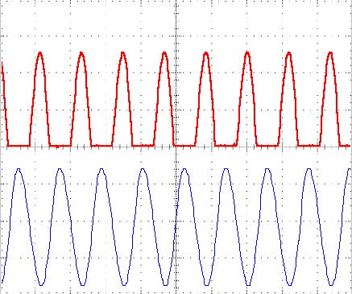
Figure 1
0 V

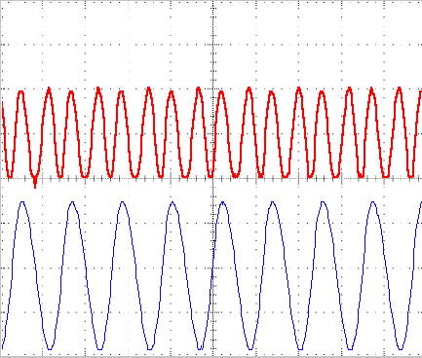
Figure 2
0 V

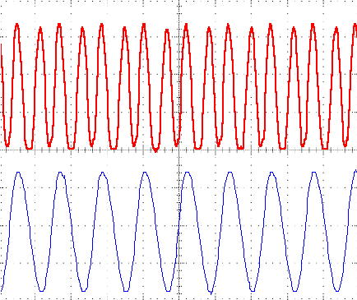
0 V
Figure 3

