Inside an Integrated Circuit

Purpose: The objective of this activity is for students to see the number, arrangement, and complexity of individual electronic components that are required to make a simple digital logic circuit (NAND gate) and compare the physical dimensions, costs, and operation of the NAND gate made with individual components to one in an integrated circuit.

Overview: To integrate: to form into a whole; to unite into something else; to incorporate into a lager unit. Integrated circuit and digital technologies have revolutionized our society as a whole and wireless technology in particular. Basically, integrated circuits combine the functions that in the past were performed by circuits constructed of individual components. The individual circuits are combined into very small and relatively inexpensive packages to perform complex functions. In other words, integrated circuits are small “black boxes” of circuits that allow the user to concentrate on what goes into the box, what comes out of the box, and not be concerned with what happens on the inside of the box.
This activity uses a simple, representative NAND gate logic circuit to illustrate the integrated circuit concept. A NAND gate circuit is constructed with discrete electronic components so that students can compare the circuit diagram of the NAND gate to the actual components mounted on the circuit board. Once the circuit is described, the students can apply input voltages to produce a truth table for the NAND gate. In contrast, a basic NAND gate integrated circuit with four gates is also available for not only physical comparison to the equivalent circuit made of discrete components but also for operational comparison. Students apply input voltages to one section of the integrated circuit and construct a truth table to verify the operation of the NAND gates.
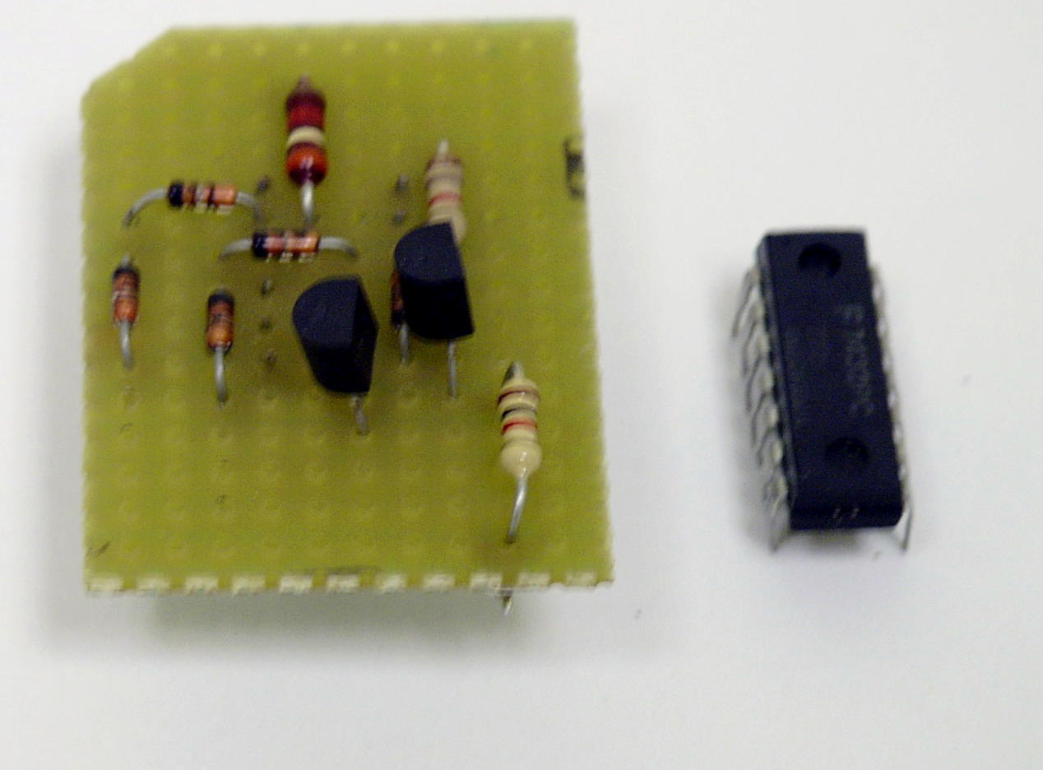
An additional interesting comparison is the cost to produce NAND gate circuitry from discrete components compared to the integrated form.

Time: One class period to develop and discuss the concept of integrated circuits. One class period to explore the NAND gate constructed of discrete components and the NAND gate integrated circuit.

Skills Required:

- Listening
- Observation
- Critical thinking
- Mathematical computation
- Writing and expression

Materials and Tools:

- The demonstration board
- Voltmeter or oscilloscope

Preparation:

- Review with the students the concept of transistors as electrically controlled valves or switches.

- Review with the students the basic electronic components: resistors, diodes, and transistors and the circuit diagram symbols used to represent those components.

- Review with the students the vocabulary used to describe digital electronics, basic logic operations and how digital electronics is the basis of modern computers.

- Review with the students how to interpret and the construct a logic truth table.

- Review with the students the proper operation of the voltmeter.

Background:

Now You’re Talking pages 7.17-7.19.

ARRL Handbook pages 7.4-7.7.

http://www.ibiblio.org/obp/electricCircuits/

What to do and how to do it:

- Distribute as a handout the circuit diagram of the NAND gate that is constructed on the activity board. Go over with the students the discrete components that make up the circuit and where they are physically located on the board.

- Provide the students with a price list of the individual components and the circuit board and task the students to calculate the cost of the circuit. Refer to catalogs of electronic component suppliers for the prices. Include in the cost estimate the cost of labor to construct and solder the circuit.

- Assign the students the task of estimating the amount of space required for the circuit by measuring the length, width, and height of the components.

- Point out to the students that the integrated circuit mounted on the activity board performs the same function as the circuit made with the discrete components, only there are four gates in the integrated circuit.

- Task the students to determine the price of the integrated circuit from the parts catalog, and the cost per gate.

- Assign the students the task of estimating the amount of space required for the integrated circuit.

- Using the voltages supplied on the activity board, ask the students to develop a truth table for both the NAND gate made of discrete components and the NAND gate in the integrated circuit. Point out that +5 volts is considered logic level 1 and 0 volts (ground) is considered logic level 0.

Data Analysis:

- Assign students to compare cost, physical dimensions, and electrical operation of the NAND gate.

Activity questions:

- Did the NAND gate circuit made with discrete components operate the same way as the integrated circuit NAND gate?

- What are the potential cost savings in using integrated circuits from the data you have collected?

- Describe how much space is saved by using integrated circuits? If the NAND gate used in this activity is assumed to represent the typical space savings that is gained by using integrated circuit technology, speculate what the size of a desk top computer would be if it was constructed of discrete components only.

- If you assume that the typical desktop computer system costs $1,000. How much would it cost if the computer were made of discrete components?

- Can you think of any disadvantages to using integrated circuit technology instead of using discrete components?

Adaptations for special needs: There should be no accommodations required for this activity.

A | B | Output
0 | 0 | 0
0 | 1 | 0
1 | 0 | 0
1 | 1 | 1

