The TinEar Receiver

By Wayne McFee NB6M

Receivers In General, and the TinEar Receiver in particular.

A radio frequency receiver is basically a device that converts the selected radio frequency to an audio frequency, which is then fed to either earphones or a loudspeaker, so that we can hear and understand the message that radio signal carries.

Radio Frequencies in the High Frequency Band are expressed in MegaHertz, with the High Frequency band covering from 3 to 30 Mega (million) Hertz.

In this case, the receiver has been designed to cover the 40 Meter Amateur Band, or from 7.000 MHz (MegaHertz) to 7.300 MHz.

Direct Conversion

The TinEar receiver is a direct conversion receiver.

It is easy to understand what that means if we think simply of the frequencies involved. In this case, with a receiver designed to tune the 40 Meter Ham Band, this means that the receiver converts the 7 Mega (million) Hertz frequency of the received signal directly to an audio frequency that we can hear.

If we are listening to a Morse code, or CW, signal, the output of the receiver will be an audio tone, in the frequency range of 600 to 1000 Hertz, depending on what exact audio tone we want to listen to.

If we are listening to a voice transmission, the output of the receiver will be the human voice, which may cover a whole band of frequencies from several Hertz up to about 3000 Hertz.

CW Reception

In order to illustrate the point, let us think of the CW signal as a 1,000 Hertz, or 1 KiloHertz tone.
And, let's say that the signal we want to listen to is being transmitted on a frequency of 7.040 MHz. In order to make it easier to understand, let's convert 7.040 MHz to 7,040 KHz.

We can convert the received 7,040 KHz signal directly to a 1 KHz tone by first generating a 7,039 KHz signal inside the receiver. This signal is generated by an oscillator we call the Local Oscillator. We then subtract the 7,039 KHz LO signal frequency from the 7,040 KHz received signal frequency by a process called mixing.

7,040 KHz
-7,039 KHz
= 1 KHz

And, we can do exactly the same thing by generating a 7,041 KHz signal with our Local Oscillator, and then subtracting the received, 7,040 KHz signal frequency from our LO frequency, again by the use of our mixer.

7,041 KHz
-7,040 KHz
= 1 KHz

Either way, all we need to do then is to amplify the resulting 1 KHz tone so that we can hear it in our earphones or loudspeaker.

Voice Reception

Now, let's talk about listening to a voice transmission. Remember that the human voice covers a range of frequencies from several Hertz up to about 3,000 Hertz. We will use the 3,000 Hertz, or 3 KHz figure to illustrate our point.

First of all, in order to transmit a voice signal in the Single Sideband Mode, we generate a stable radio frequency, and then either add or subtract the audio frequency of our voice from that stable radio frequency, through the use of a mixer.

The frequency of our stable RF signal is called the Carrier Frequency.

If we add the frequency of our voice to our stable RF signal, then we say that we are transmitting on the Upper Sideband of the Carrier Frequency. If we subtract the frequency of our voice from the stable RF signal, then we say we are transmitting on the Lower Sideband of the Carrier Frequency.

In either case, the Carrier Frequency is the dial frequency we tune our radio to.

It is customary to use Lower Sideband to transmit voice signals in the 40 Meter Amateur Band. So, in order to listen to a Lower sideband signal, we simply generate an RF signal with the Local Oscillator that is 3 KHz above the received signal frequency, and then use our mixer to subtract the received signal frequency from the LO frequency.

Let's say that the Lower Sideband signal we want to listen to is being transmitted on 7,250 KHz. We generate a 7,253 KHz signal with our LO, and subtract the 7,250 KHz received signal frequency from the 7,253 KHz frequency of our LO, resulting in an audio frequency of 3 KHz.

7,253 KHz
-7,250 KHz
= 3 KHz

In practice, the human voice is not a single tone, but is an audio signal that may cover from a few Hertz up to about 3 KHz. So, when we want to tune in a Lower Sideband signal, we simply tune our LO until the desired voice signal sounds right. If we tune down in frequency towards a Lower Sideband signal, the audio frequency heard will start out high and will get lower as we continue to tune down in frequency. If we tune up in frequency towards a lower sideband signal, the audio frequency heard will start out low and will get higher as we tune up in frequency.

Again, we simply tune our LO until the voice sounds right, not too much bass and not too much treble. Once the received signal frequency is converted to the correct audio frequency, we simply amplify it and send it to earphones or a speaker so that we can hear it.

The TinEar Receiver, Simplicity Itself

The TinEar receiver is a very basic, Direct Conversion design. It uses a Variable Frequency Oscillator as its Local Oscillator. The received signal and the LO signal are both sent to a Mixer, where the received signal is converted directly to audio. And, finally, that audio signal is amplified by an Audio Amplifier chain and sent to earphones so that we can hear it.

In order to simplify a circuit description, we describe a circuit in terms of circuitry "Blocks", each of which performs a distinct and separate function.

In this case, the TinEar receiver is made up of four circuitry "Blocks". They are the Local Oscillator (in this case a Variable Frequency Oscillator), Mixer, Audio Preamplifier, and Audio Output Amplifier.

In order to complete the receiving system, we need an Antenna, Earphones, and a Power Supply, in this case a 9 Volt battery. The Block Diagram of the TinEar receiver is shown below.

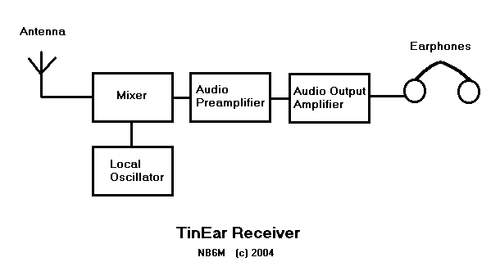

TinEar Receiver Functional Summary

As described above in the details of how a Direct Conversion receiver works, the received signal is taken from the Antenna, and routed, along with the Local Oscillator signal, to the Mixer, where the signal is converted directly to audio. From there, the audio signal is amplified by the Audio Preamplifier and Audio Output Amplifier stages and sent to Earphones so that we can hear the message.

